DRĄSUTIS, EVALDAS

iO

Marconilaan 16, 5621 AA Eindhoven

September 12, 2024

Project report

Documentation on project progress

|  |  |  |  |
| --- | --- | --- | --- |
| Date | Version | Status | Reviewees |
| 24-11-2024 | 0.1 | Review |  |
| 09-12-2024 | 0.2 |  |  |

Contents

Context 6

Glossary 7

1. The Assignment 8

1.1. Introduction 8

1.2. Problem/Opportunity 8

1.3. Goal 9

1.4. Research Questions 9

1.4.1. Main research question 9

1.4.2. Sub Questions 9

1.5. Approach to the research 10

2. Description of the process 10

2.1. The process 10

2.2. Results 11

2.2.1. Interactive map 11

2.2.2. API implementation 11

2.2.3. Navigation and routing 11

3. Implementation 12

3.1. Back-end work 12

3.1.1. Public transportation API implementation 12

3.1.2. Geographical data analysis 14

3.1.3. Navigation data API 14

3.2. Front-end work 16

3.2.1. Leaflet map & plugins 16

3.2.2. Disturbance box 19

3.2.3. Responsive layout 19

3.2.4. Charge Station overlay 21

4. Conclusion and recommendation 21

4.1. Conclusions 21

4.2. Recommendation 22

3. Reflection 22

3.1. Personal reflection 22

3.2. Project Reflection 22

3.2.1. Professionally 22

3.2.2. IT field 22

3.3. Learning outcomes 23

3.3.1. LO 1: 23

3.3.1.1. Justification 23

3.3.1.2. Evidence 23

3.3.2. LO 2: 23

3.3.2.1. Justification 23

3.3.2.2. Evidence 24

3.3.3. LO 3: 24

3.3.3.1. Justification 24

3.3.3.2. Evidence 24

3.3.4. LO 4: 25

3.3.4.1. Justification 25

3.3.4.2. Evidence 25

3.3.5. LO 5: 25

3.3.5.1. Justification 26

3.3.5.2. Evidence 26

3.3.6. LO 6: 26

3.3.6.1. Justification 26

3.3.6.2. Evidence 27



**GRADUATION-INTERNSHIP PORTFOLIO BACHELOR-ICT**

**FONTYS UNIVERSITY OF APPLIED SCIENCES**

|  |  |
| --- | --- |
| **Student:** | |
| Family name, initials: | **Drasutis, E.D.** |
| Student number: | **3917835** |
| project period: (from – till) | **3 September 2024 – February 2025** |
| **Company:** | |
| Name company/institution: | **iO** |
| Department: | **ICT** |
| Address: | **Marconilaan 16, 5621 AA Eindhoven** |
| **Company mentor:** | |
| Family name, initials: | **Van den Heuvel, J.V.D.H.** |
| Position: | **Lead Software Engineer** |
| **University teacher:** | |
| Family name, initials: | **Sivaramakrishnan, K.S** |
| **Final portfolio:** | |
| Title: | **Creation of Travel Coach** |
| Date: |  |

Approved and signed by the company mentor:

Date:

Signature:

|  |  |  |  |
| --- | --- | --- | --- |
|  |  |  |  |
|  |  |  | |  | | --- | |  |  |  | | --- | |  | |
|  |  |  |  |
|  |  |  |  |
|  |  |  |  |
|  |  |  |  |
|  | EV | Electric Vehicle | Transportation vehicle that is supplied with electricity which is more eco friendly |
|  | SCRUM methodology |  |  |
|  | client-server architecture |  |  |

# Abstract

In this document you will find, explorations of the development and integration of the iO TravelCoach system

In this report document you will find the methodologies, research insights, and professional products delivered throughout the projects development progress. The document offers a comprehensive guide to the development and deployment of the requested system.

The TravelCoach system is a innovative employee navigation tool designed to enhance commuting experiences by providing real-time transportation advice, personalized route notifications, and proactive disruption alerts. The system makes use of advanced API integrations, including GTFS and OpenStreetMap data, to deliver accurate, user-specific travel recommendations.

The key aspects of the project involves identifying and addressing technical challenges such as collecting and processing route data, implementing security measures to ensure data privacy, and designing an intuitive user interface for seamless interaction. Applying various research methods, including user surveys and user testing to prioritize essential features like ease of use, real time updates and real time notifications.

The project outcome includes a scalable backend system developed in Spring Boot, a responsive frontend using React, Leaflet maps and component library MUI. The results is a user-centric navigation tool tailored to employees’ needs addressing real-world commuting challenges.

# Acknowledgements

I would like to express my deepest gratitude to all those who supported me during the course of this project. First and foremost, I would like to thank my mentor, Jorith van den Heuvel, for their invaluable guidance, encouragement, and expertise, which greatly contributed to the successful completion of this project.

I also extend my sincere thanks to the team at iO for providing me with the opportunity to work on a real-world development project in a professional environment. Their support, resources, and insights have been instrumental in enriching my learning experience and shaping the outcomes of this project.

Lastly, I am grateful to my university instructors and peers for their constructive feedback and advice throughout the internship period. This journey has been a valuable learning experience, and I deeply appreciate the contributions of everyone involved.

# Context

As a full-stack developer I was assigned to the iO TravelCoach project allowing me to take control of all the development streams of this project. From creating the architecture to the design of the websites front-end. The company requires the intern to assist in creating a new internal tool. The iO TravelCoach, which aims to improve employee travel planning. This tool will collect employee information from their profiles and determine the route information between their residences and the company offices. Additionally, it will provide live updates to inform employees about unforeseen traffic delays. The solution should utilize various public transportation APIs to accommodate different country schedules, as different countries use different software for local transportation. For example, in the Netherlands, it is common to use Google Maps, NS, or 9292 to get information about public transport (trains, trams, and buses), but the navigation applications could differ in other countries where iO offices are located. The application currently lacks research information, allowing developers to choose and modify development factors such as technologies and architectural approaches. This will require the intern to perform extensive documentation and research to describe the best approach suited for the stakeholders. The goal of the software is to integrate and synergize with different country navigation applications primarily used for public transportation.

**Recent developments**

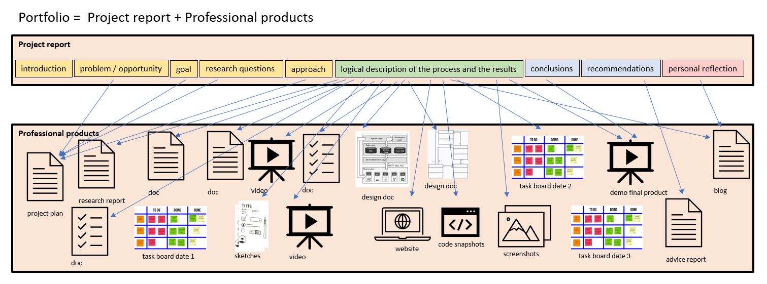With recent development to the project one of the features “booking company cars” was stated as no longer necessary due to complications of continuing this service for employees.

<https://fhict.instructure.com/courses/13872/pages/it-competences-and-learning-outcomes?module_item_id=1093614>

|  |  |  |  |
| --- | --- | --- | --- |
| Lo | Lo name | Description | Grade |
| 1 | Professional duties | You can adapt your working activities, style and communication based upon what the actual situation requires, given the assignment, the company and the team around you. |  |
| 2 | Situation-Orientation | You apply your previously acquired knowledge and skills in a new and authentic context to deliver relevant and valuable results for the project and company. |  |
| 3 | Future-oriented Organization | You explore the organizational context of your project, make business, sustainable and ethical considerations and manage all aspects of the execution of the project. |  |
| 4 | Investigative Problem solving | You take a critical look at your project from different perspectives, identify problems, find an effective approach and arrive at appropriate solutions. |  |
| 5 | Personal Leadership | You are entrepreneurial around your projects and personal development; you pay attention to your own learning ability and keep in mind what kind of IT professional and/or what type of positions you aspire to. |  |
| 6 | Targeted Interaction | You determine which partners play a role in your project, collaborate constructively with them and communicate appropriately to achieve the desired impact. |  |

# 

|  |  |  |  |
| --- | --- | --- | --- |
|  |  |  |  |
|  |  |  | |  | | --- | |  |  |  | | --- | |  | |
|  |  |  |  |
|  |  |  |  |
|  |  |  |  |
|  |  |  |  |
|  |  |  |  |

# The Assignment

## Introduction

The Assignment that I focused on at iO was the Travel Coach functionality. This solution was aimed to assist company’s employees to have an easier time with a cross-campus collaboration and suggesting personnel to opt for greener energy such as public transportation.

## Problem/Opportunity

The internship project aims to address several specific challenges and opportunities within the development of the ICoach application, but primary opportunities arise from development of a new proof of concept for the idea.

Firstly, there is a need for employees of the company have real time public transportation and disturbance notifications on their campuses to manage their transit time more effectively. By implementing feature such as event-based messaging system from region-based transit companies, would reduce employees need to check for external sources to manage their public transport schedules. This would encourage productivity in the workplace and motive users to opt for public transportation.

Secondly, the platform needs assistance in allowing an easy way to rent company’s Electric Vehicle(EV) and track local EV charging stations to support employees who rent and travel with company’s cars for cross campus meetings. By providing interactive map with locations of company cars and local charging stations, would reduce the employees need to search for individual steps. Making it an easier interaction for staff to obtain transportation and travel cross campus.

In addition, to these functional requirements there is various non-functional aspects of maintainability, fast and reliable performance, bug-free solutions and secure handling of user and client data are important parts of the product. Adhering to various programming principles such as Object-Oriented (OO) and SOLID principles, implementing various testing techniques, and ensuring to GDPR compliance are integral part to delivering an effective solution.

## Goal

The goal of this internship is to develop a proof-of-concept project showing the benefits of developing an internal tool that assists iO employees with travel planning and commuting optimization suggestions.

The software should suggest their commutes by providing real-time updates on traffic conditions and public transport options. Suggest eco-friendly travel alternatives such as public transport, electric vehicle (EV) charging spots, in line with the company's sustainability goals. Integrate seamlessly with existing company systems and employee profiles. Offer personalized route recommendations based on the user’s profile and real-time conditions.

The project aims to create a custom solution tailored specifically for iO employees, which distinguishes it from generic travel apps. By doing so, it will improve employee satisfaction, support sustainability initiatives, and optimize commute times for the workforce spread across multiple locations.

## Research Questions

## Main research question

How can a transportation assistant system be developed and integrated within the iO employee application to provide personalized commuting information and notifications for iO employees?

## Sub Questions

1. How can a student acquire real-time traffic information about public transportation alternatives, traffic information and EV charging station availability?
2. How to develop a system to provide notifications based on personalized profile routes?
3. How can the architecture of a public transit application be designed to efficiently integrate real-time data.
4. What are expected levels of security required to implement to be defined as secure
5. How will the intern plan to assess and measure the success of iO TravelCoach integration?

The research document can be found following this link:

Link –

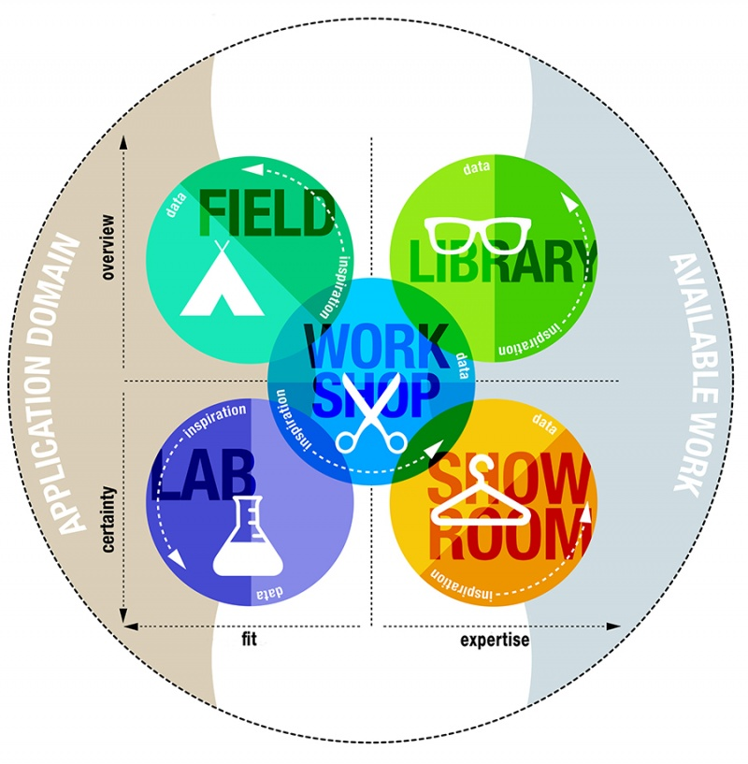

Figure 1: DOT Framework

## Approach to the research

For my approach to the internships project. I applied several methodologies and design frameworks to assess my research.

For instance, using AGILE/SCRUM for assisting the development approach by having weekly retrospectives and sprint planning with my project stakeholder. Working in this way I’m constantly involving my stakeholders in the projects life cycle and getting feedback on my progress.

For each of my research topics I have been applying the DOT Framework (Fontys Hogeschool ICT, -). The advantage of using it is to build research with “**Field**, **Library**, **Workroom**, **Showroom**, **Lab**” so that I can verify that my research has connection to my project tasks.

# Description of the process

## The process

The approach to the project process began with the development of a structured plan to simplify tackling the project’s complexities. The project was divided into 12 sprints, each estimated to last two weeks. At the start of every sprint, a detailed plan was created to ensure alignment with the project timeline and maintain steady progress. The sprints were organized as follows:

* **Sprint 1-2:** Requirement gathering and initial research, including exploring technologies and defining project scope.
* **Sprint 3-4:** Designing the application architecture and prototyping the initial UI/UX design.
* **Sprint 5-6:** Development of core backend functionality, such as integrating APIs for route disruptions.
* **Sprint 7-8:** Frontend implementation and ensuring seamless communication between front-end and back-end components.
* **Sprint 9-10:** Testing, debugging, and enhancing system features based on feedback from stakeholders and users.
* **Sprint 11:** Finalizing the system with additional tests and security measures.
* **Sprint 12:** Deployment, user training, and preparing documentation for handover.

The purpose of these sprints was to follow an iterative approach, ensuring regular feedback, adaptability, and delivery of functional requirements of the project. This iterative process is detailed in the **project plan,** which highlights the emphasis on incremental development and continuous improvements.

The project process followed an iterative and incremental approach similar to mixture of Scrum and Agile rituals. The planning phase was crucial for maintaining focus and ensuring steady progress. The process included 12 sprints, each lasting two weeks, where the following steps were carried out:

* **Gathering information on tasks:** Understanding and documenting requirements and expectations at the start of teach sprint.
* **Documenting the process and plan:** Creating detailed plans and maintaining documentation to track progress.
* **Prototyping:** Developing initial versions of features for early feedback.
* **Development:** Building functional components based on the prototype.
* **Feedback loop:** Gathering input from the mentor of colleagues through sprint reviews or informal discussions.
* **Testing:** Writing and running necessary tests to ensure system reliability and functionality.
* **Version control:** Committing changes to Git regularly for versioning and collaboration.

This process closely aligns with key points of Scrum practices which are:

* **Spring planning:** At the start of each sprint, tasks were planned based on priority and feasibility, ensuring alignment with project timeline.
* **Daily Stand-ups:** Informal updates with the team and mentors to help track progress and address any issues.
* **Sprint Review:** Feedback sessions allowed th team to demonstrate completed work and identify areas for improvement.
* **Sprint Retrospective:** Reflecting on the previous sprint’s successes and challenges helped refine the process for subsequent iterations.

At the company, sprint planning meetings would be held every Tuesday to discuss retrospectives, tasks completed, issues encountered and new tasks for the next sprint. This ensured consistent progress while adapting to new insights and challenges.

By following this approach, the project stayed on track having regular feedback loops provided allowing continuous improvements to be applied, ultimately delivering a robust and reliable solution.

## Results

The internship yielded several significant results that contribute to addressing challenges in the development of the iO ICoach application. The project integrated interactive mapping, navigation, and disruption notification features, emphasizing usability, responsiveness, and a structured architecture.

## Overall Architecture

The project is build on a client-server architecture with the following key components:

1. **Frontend:**
   1. Developed using React, integrated with Leaflet for mapping functionalities.
   2. Features responsive UI design that dynamically adju7sts to various screen sizes
   3. Implements geolocation, routing , and disruption notification in an intuitive interface
2. **Backend:**
   1. Built with Java Spring Boot to handle API integration, data processing, and business logic.
   2. Integrates with external data sources such as NS api, 9292 API, and GTFS data for trip and disruption information.
   3. Uses OpenTripPlanner for routing and public transportation data processing.
3. **Data Sources and APIs:**
   1. NS API for train disruptions and trip planning.
   2. 9292 API for bus schedules and disruptions.
   3. GTFS data for public transit schedules and stops.
4. **Deployment and hosting:**
   1. Backend and frontend deployed in a development environment for testing purposes but also ensuring scalability and accessibility for uses.

**Context Diagram:**

(Include a high-level context diagram showing the interaction between frontend, backend, APIs, and external data sources.)

## Research Summary

The research phase addressed critical questions related to mapping, routing, and public transportation APIs. The following highlights the key findings:

**Mapping and Routing**:

* Leaflet was chosen for its flexibility and extensive plugin support, such as Leaflet Routing Machine.
* Customizations improved usability by aligning map and routing features with the application’s UI design.

**Public Transportation APIs**:

* NS API provided real-time train schedules and disruptions.
* GTFS data enabled detailed trip planning and stop information.
* OpenTripPlanner facilitated multi-modal routing, enhancing user navigation.

**Performance Optimization**:

* Geolocation and real-time updates were optimized for minimal latency.
* API responses were cached to reduce redundant calls and improve performance.

## Design and Implementation

The project followed a bottom-up approach for designing and implementing the following components:

1. **Interactive Map**:
   * Used Leaflet for dynamic map rendering.
   * Incorporated geolocation with toggle functionality and custom container styles for routing results.
2. **Backend API Implementation**:
   * Developed Spring Boot services to fetch and process trip and disruption details.
   * Integrated NS, 9292, and GTFS APIs for real-time and schedule-based transit data.
   * Employed OpenTripPlanner for route calculations and transit analysis.
3. **Navigation and Routing**:
   * Customized Leaflet Routing Machine for enhanced itinerary presentation.
   * Styled routing results with CSS modules for improved readability and usability.
4. **Testing and Deployment**:
   * Conducted unit and integration tests to validate system functionality.
   * Deployed the application in a staging environment for stakeholder feedback before final production.

## Iterative Development and Results

The iterative development approach ensured incremental delivery of functional components, enabling regular feedback and continuous improvement. The results include:

* **User-Friendly Navigation:** Real-time updates, intuitive map controls, and optimized routing display.
* **Seamless Integration:** A cohesive system where the frontend and backend interact with external data sources to provide reliable transit information.
* **Robust Functionality:** Enhanced disruption handling and trip planning features tailored for public transit users.

# Conclusion and recommendation

## Conclusions

This internship project let to new finding and contributions to the development of iO travel coach platform. By consistently collecting information, researching and applying new approaches to the problem and getting feedback on my solutions has driven me to achieving some milestones of the systems features. The introduction of the transportation routing and disturbance notification features are one of focus of this project’s development.

## Recommendation

After working on iCoach applications for about 4 months I have gathered some recommendation that I would like to see implemented in the near future:

1. Non-functional improvements
   1. Write more detailed user manuals.
2. Research & development
   1. Needs to research into a better way of handling bigger data files like GTFS that depend on GeoJson type.

# Reflection

## Personal reflection

During my internship project period, I have gained significant knowledge and experience in a professional field of ICT. The hands-on experience allowed me to apply my theoretical knowledge from Fontys to real world scenarios, enhancing my development in problem-solving skills and technical proficiency. I noticed an improvement to my ability to design, implement which aligns with my personal development goals of becoming a full stack developer. The internship has also provided me with a better understanding of communication and project management within professional environment.

## Project Reflection

During my internships project lifecycle, I have obtained significant knowledge and experience professionally and within the desired field.

## Professionally

In the aspect of professional development, I have learned how to manage my projects planning more effectively and collaborate with my company’s stakeholders/mentor. I have improved my skills in agile methodologies and advanced my ability to communicate technical concepts clearer with my company mentor.

## IT field

In the aspect of IT field, I have applied myself to developing in a versed technological stack.

Typescript – has allowed me to build an understanding of typescript syntax and best practices. I have also developed my full-stack skills by working on both front-end and back-end components for the project. I have researched into Vue, React which provided me with some challenges to work towards to improve these skills.

## Learning outcomes

## LO 1:

(Professional duties)

You are able to adapt your working activities, style and communication based upon what the actual situation requires, given the assignment, the company and the team around you.

### Justification

* Analysis: Conducted research and analysis on necessary requirements to understand the projects scope and objectives.
* Design: Created design components, including UI wireframes and system architecture.
* Realize: Developed and implemented software following the company’s best practices.
* Advise: Provide suggestions on system technology stack and technical features.
* Manage & Control: Maintain the project timeline ensuring the most valued features are met with the expected deadlines adhering to quality standards.

### Evidence

* Project plan
* Research document

## LO 2:

(Situation-Orientation)

You apply your previously acquired knowledge and skills in a new and authentic context to deliver relevant and valuable results for the project and company.

### Justification

During the period of the Internship, I have applied my knowledge and skills obtained from my study at the Fontys university to the provided challenges of real-world project. Skills applied to the project include:

* Functionality Creation
  + Utilized CRUD and SOLID principles to achieve a dynamic software solution thus enhancing the user experience.
* Planning
  + I tried to prioritize the most crucial features and estimating my development time to ensure timely delivery of products.
* Functionality Improvement
  + Continuous feedback from the stakeholders on the new implementations assisted me in reworking the features based on given notes.

### Evidence

* Research document
* Wireframe design
* Trello board

## LO 3:

(Future-oriented Organization)

You explore the organizational context of your project, make business, sustainable and ethical considerations and manage all aspects of the execution of the project.

### Justification

* In terms of functionality, ethics came into play as to raising a question if scrapping is an ethical option considering the latest discussions on new technology laws.
* In terms of sustainability, the source technology used for the projects tools is license free allowing the business to use the features without needing to pay for subscription.

### Evidence

The leaflet maps and routing system is open-sourced projects.

## LO 4:

(Investigative Problem solving)

You take a critical look at your project from different perspectives, identify problems, find an effective approach and arrive at appropriate solutions.

### Justification

I approached the project with critical outlook, researching and identifying the various underlying challenges:

* Problem Identification
  + Regular review meetings with mentor to share findings and encountered problems that need a different approach.
* Approach to the problem
  + Applied various problem-solving techniques to develop an effective solution to encountered challenges, including brainstorming sessions with peers.
* Solutions
  + Implemented solutions were technically working and aligned with the projects stated objectives.

### Evidence

* Research documents
* Notebook notes

## LO 5:

(Personal Leadership)

You are entrepreneurial around your projects and personal DEVELOPMENT; you pay attention to your own learning ability and keep in mind what kind of IT professional and/or what type of positions you aspire to.

### Justification

I have shown my personal leadership skills by being initiative in my projects functionality and focusing on my personal development:

* Entrepreneurial Approach
  + Took initiative in providing innovative new ideas for the functionalities I was working on.
* Professional Aspirations
  + Reflected on my career goals and took steps to target my internship experience to my aspired career path.
* During this internship I found a bigger affinity for front-end development but my aspirations to becoming a better full-stack developer is still persistent.

### Evidence

* Wireframe design
* Typescript tutorials

## LO 6:

(Targeted Interaction)

You determine which partners play a role in your project, collaborate constructively with them and communicate appropriately to achieve the desired impact.

### Justification

I have collaborated effectively to achieve the projects goals:

* Stakeholder identification
  + Got in contact with iO developers responsible for development of the main employee application to investigate the technological stack and the structure of the project for the best process of merging of the feature to the main application.
* Communication
  + Maintained regular communication with the stakeholders to inform the parties of the current progress and align any concerns they might have with new implementation.

For the duration of the internship, I mostly communicated with my company mentor and my project accessor. For the company mentor we mostly communicated via live meeting at the company displaying the progress and current problems to access the situation.

For my internship mentor we would have weekly meetings on Tuesdays at (9:30AM). During these meetings I would try to provide all my problems for the mentor for some brainstorming opportunities to find a solution on the existent problem.

### Evidence

* Notebook notes
* Screenshots from chats with coworkers.

This picture shows discussion on the technology stack with senior developer that was responsible for creating the employee tool.

Communication with the project mentor on the level of confidentiality of the data.